Data Security Compliance Use Cases

CNCF Compliance-grc
Hubbert Smith – hubbert@i4ops.com
Slack HubbertSmith https://cloud-native.slack.com/archives/D06PVNSQ5AB

1 Compliance Use Case Whitepaper Objectives 3
2 Commonalities 5
3 Outside Scope of this paper 5
4 Key Terminology 5
5 Problem Framing 7
5.1 Common Data Breaches 7
6 PERSONAS 8
6.1 CISO-office Persona 9
6.2 BISO Persona Business Information Security Owner 10
6.3 Programmer and Sysops Personas 11
6.4 Credentialed Data User, Analyst Persona 11
6.5 3rd Party Credentialed User Persona 12
7 Policy definition, and assignment to sensitive assets 13
7.1 Compliance Catalog Risk and Policy 13
7.2 Policy-risk-profile and Digital Asset Catalog 14
7.3 Assessment 14
7.4 Digital Asset Catalog (locations): where is my (sensitive) data 14
7.5 Compliance boundaries (locations): Storage Volumes 15
7.6 Consistent Audit, spanning multiple organizations 15
8 REFERENCE 17
8.1 NIST OSCAL for regulation controls representation 17
8.2 NIST access policy tool 17
8.3 CIS data management policy template: 17
8.4 Valid ID: root cause of most data breaches 17
8.5 Data Lifecycle (copies and derivatives of a Digital Asset and GID) 18
8.6 [Example] Digital Asset CATALOG based on policy-risk-profile 18
8.7 Verizon Data Breach 2023 18
8.8 CNCF Example Security Use Case 18

Change Log
V1 - 2024-May-06 | First draft | Hubbert Smith
V2 - 2024-may-13 | Mission, success criteria, definitions, digital asset, storage volume | Hubbert Smith
V3 – 2024-may-29 | Clarified Compliance mission, success criteria and Auditing | Hubbert Smith
V4-2024-june-20 | Improved compliance and policy definitions. Added reference to SUSTO. Added references to OSCAL regulation controls representation. Clarified role of Programmer/Sysops and auditing. Added CIS references | Hubbert Smith
V5-2024-sept-23 | Clean up success criteria, references and footnotes | Hubbert Smith
V6-2024-oct-08 | Scrub mission, Adjust headings, punctuation, trim text | Hubbert Smith  Ballard Pritchett
V7-2024-oct-11 | Adjust for Anca input relating to OSCAL | Hubbert Smith

American Council for Technology - www.actiac.org
Authorization to Operate (ATO) https://www.actiac.org/system/files/2024-03/ATO%20as%20Code.pdf
Federal Information Security Modernization Act of 2014 (FISMA) guidelines
CNCF post the document to –
https://github.com/cncf/tag-security/tree/main/community/working-groups/compliance/content

Compliance Use Case Whitepaper Objectives
This paper serves to accelerate adoption of data security practices essential to data-driven innovation.
This paper provides a “user point of view” simple, consistent and easy to implement GRC-relevant auditing of sensitive data-in-use handled by single and multiple organizations. In the interest of accelerated adoption.
This paper supports broader GRC objectives:
- Retain consistency with industry guidelines and best known methods from GDPR, NIST, CIS and similar.
Regulation controls representation: as defined https://pages.nist.gov/OSCAL/
Policy validation tools: NIST’s ACPT (Access Control Policy Tool) https://csrc.nist.gov/Projects/Access-Control-Policy-Tool/
Organizational Policy: as defined by CIS data management policy template:
https://www.cisecurity.org/insights/white-papers/data-management-policy-template-for-cis-control-3
ATO as code (authorized to use) - Federal Information Security Modernization Act of 2014 (FISMA)
https://www.actiac.org/system/files/2024-03/ATO%20as%20Code.pdf
- Accelerate adoption: Accelerate adoption: simple, consistent, easy to understand, easy to implement, and easy to use GRC-relevant governance, risk management and auditing; focused on sensitive data-in-use handled by single and multiple organizations.
Ease of handling sensitive data shared by multiple organizations and Ease of sharing audits of sensitive data handling across multiple organizations
Ease of Implementation: Low-friction tools for monitoring data breaches, including assets accessed by third parties.
Asset Identification: Simple methods to classify sensitive digital assets, assign policy and identify owners.
Scalability: Solutions suitable for projects of any size and accessible to employees and third-party participant and multiple parties.
- As an example: the U.S. Army Corps of Engineers may share confidential construction data with contractors and later request an audit to ensure compliance with security policies.
Asset Cataloging: for sensitive digital assets, with assigned data handling as defined by organizational policy, and defines sensitive digital asset ownership, location, and access logs.
see nist oscal for further insight on regulation controls representation: https://pages.nist.gov/OSCAL/
Compliance audit: for sensitive digital assets, comparing assigned data handling policy, with location and access logs. To confirm compliance to organizational policy including 3rd party data access and data handling
Sharing sensitive data across multiple organizations is the norm. GRC is required
Therefore consistent auditing sensitive data across multiple organizations is required.

Commonalities
Our objective is to accelerate adoption. Accordingly, we seek commonalities:
Sensitive data-in-use is common to many vertical industries, including:
Power generation, transmission, distribution and consumption, Supply Logistics, Genomic research and development, Silicon research, development and manufacturing, Healthcare, Finance and banking, Education, Edu-tech, Manufacturing both discrete and process, Telecom, Oil and Gas, Government operations and finance, Scientific research.
Sensitive data-in-use is common to many general IT practices, including:
Systems of record data for general business (database, financial ledger)
Systems of analysis for analytics, data science, AI training, and AI inference (sensitive data)
Systems for business continuity and disaster recovery (backup and snapshot)
Sensitive data-in-use is common to these IT hardware and virtual Infrastructures, including:
Physical “bare metal” servers (such as Linux servers or Windows servers),
Virtual Machines (such as KubeVirt, KVM or VMware),
Containers (such as Docker, ContainerD or Podman),
Clusters (such as Kubernetes, GKE, EKS, AKS, OpenShift, Tanzu, Rancher).
as used in Private data center, or Public Cloud, or some hybrid combination.
Therefore, standardization of audits of data-in-use, including data sharing with other organizations and 3rd parties, is a matter of safe handling of data AND common methods of compliance data security auditing of data-in-use.
Audits will use common tools to produce common and consistently formatted output.

Outside Scope of this paper
This document does not provide exhaustive legal compliance assessments or interpretations of legal obligations such as GDPR, HIPAA, CCPA, and others. Additionally, it does not cover security architecture or automated asset discovery processes. Topics such as encryption of data-at-rest or in-motion are addressed separately. This version streamlines content while preserving essential information.
Tooling is covered elsewhere.

Key Terminology
Data Breach: An unauthorized event where sensitive data is taken from an authorized data volume to an unauthorized destination, typically involving GRC compliance-relevant data sets.
The essence of GRC-relevance is
- Reduce risk of sensitive data breach and associated business and legal consequences;
- To become aware of sensitive data breach in hours (not months) and know root causes of said loss;
- take corrective action based on sensitive data loss root causes.
Data Volume: Logical storage unit providing contiguous access to physical blocks on disk drives or solid-state devices. Examples include ext4 file systems, relational data, and cloud volumes. The data volume establishes the approved location; and logging of the data volume captures GRC-relevant approved and non-approved data movement
Data Volume GRC Logging: using software open source tools such as auditd or similar to capture user logins, user access to data assets, lateral data movement in/out of data volumes, network data movement in/out of data volumes. This logging data will be used during GRC-relevant audits.
Digital Asset: a unique GRC-relevant sensitive digital asset, with unique ID. A single digital asset (ex. Sales data), may have plural instances (ex. sales data-Q1, sales data-Q2, sales data-Q3).
- tracked in digital asset catalog,
- stored in GRC-observable data volume,
- with GRC relevant logging, as defined herein.
Digital Asset Catalog: GRC-relevant listing of sensitive digital assets, unique IDs, assigned policy, assigned org owner, assigned human owner. Catalog also includes ongoing GRC-relevant tracking such as asset location(s) (datacenter:server:storage), data handling events, data access/sharing events, policy changes, and asset deletion/destruction events.
Digital Asset Classification: same as assigning a specific policy to digital assets.
Digital Asset Policy: each unique sensitive digital asset will be assigned a policy and recorded in the digital asset catalog. (see also Policy and Digital Asset Catalog).
Digital Asset Instance: A unique, homogeneous, non-public, dynamic data set with a unique identifier and owner. May have multiple copies, derivatives, or snapshots. May be stored as relational/block data, or file data, or blob data.
Digital Asset Location: Physical location (datacenter:server:storage), where a digital asset is stored, including datacenters and specific computer or storage systems.
Digital Asset Owner: Business units shall designate individuals with responsibility and authority for stewardship of sensitive uniquely identified digital assets.
Typically, a CISO or BISO are the designated individuals with responsibility and authority for:
- Using sensitive data; approving/revoking access within the organization and with external 3rd parties
- Securing sensitive data, establishing policy, approved locations, and approved access for given asset(s)
- Overseeing data operation, conducting self-audits and 3rd party data handling audits.
Digital Asset Sharing: Process of providing access to, or sending data to, approved individuals and partners. Digital Asset Sharing shall record, uniquely identified asset(s) to be shared, and contractual terms defining which individuals have approved access to said-assets, defining approved handling and on-going security of said-assets. See nist oscal for further insight of regulation controls representation: https://pages.nist.gov/OSCAL/
Digital Workspaces: Any location where data can be accessed, edited, read, or transferred, including PCs, servers, and cloud systems.
Enterprise Environment: Pre-existing systems and cybersecurity safeguards, such as two-factor authentication and role-based access controls.
Exfiltration: Unauthorized data handling, transmission, movement, or storage.
Exfiltration Audit, start of day: Testing to confirm data exfiltration protections are in place. Programmatic attempts to unauthorized exfiltrate dummy test data from secured locations, logging results as "exfiltration prevented" or "exfiltration allowed".
Exfiltration Audit, ongoing: logging all unauthorized attempts to exfiltrate sensitive digital assets from secured locations, logging results as "exfiltration prevented" or "exfiltration allowed".
Export: Authorized data handling, transmission, movement, or storage, typically pre-authorized and logged.
Export Audit: Programmatic confirmation of authorized export of dummy test data to defined destinations, logging results as "authorized export allowed" or "authorized export prevented".
FTE: Full-time employee of the Digital Asset Owner organization (see Digital Asset Owner)
GRC-controlled digital assets and events: GRC-controlled-data shall be handled in accordance with written organizational governance, risk management, and compliance:
- GRC-designated sensitive digital assets, which, if breached, carry legal and business consequences. Assets include but are not limited to:
- Government restricted Personally Identifiable and health Info such as SSN#, date of birth, DL, Passport, and medical records. GRC-designated data also includes Financial information such as credit cards, bank accounts, loan info, payment/purchase histories, credit rating.
- GRC-designated Business confidential, trade secrets and Intellectual property such as sales/customer histories, supply histories, manufacturing information, software-firmware related secrets, chemical-related secrets, computer chip designs, manufacturing and other information covered under non-disclosure agreements.
Policy: Policies are a standard risk framework. Policy classifications are defined by authorized/responsible CISO persona. (by example: top secret, secret, confidential).
- Each policy defines allowed access, access approvals, approved locations, and required responses for unauthorized access or breaches.
- Each unique sensitive digital asset will be assigned a policy and recorded in the digital asset catalog.
Policy-as-code and Compliance-as-code: Methods for defining and enforcing security policies for sensitive digital assets.
Third Parties: Any individual, contractor, consultant, team, or business partner accessing data;
who are not Digital Asset Owner responsible for data GRC. (see Digital Asset Owner)
Third party data sharing: Data sharing policies attached to each sensitive digital asset define
1) who has the authority to share the specific digital asset;
2) which parties may the specific digital asset be shared with;
3) the contractually mandated security measures, terms of access, handling and auditing.

Problem Framing

Common Data Breaches
See reference section: IBM cost of data breach report 2024
See https://en.wikipedia.org/wiki/List_of_data_breaches
Insider threats - Whenever humans touch data, there is risk. Credential abuse is typically the root of unauthorized exfiltration. Data breaches, cited in daily news, involve credentialed employees, credentialed contractors, lax account/password care, and syspriv abuse.
- 6% Valid credentials obtained via social engineering
- 7% Valid credentials abused by malicious insider
- 11% Valid credentials obtained by zero day
- 12% Valid credentials exploited with cloud misconfiguration (demo account, snowflake)
- 15% Valid credentials obtained by Phishing
- 16% Valid credentials stolen and then abused
- 67% of data breaches directly relate to valid credentials, according to this statistically valid data sample
Data Breach is STILL daily news … (Why?) Humans touching data and credential abuse is a frequent source of breach. Departing employees, contractors, credential abusers, sysadmin abuse, sloppy cloud credentials. NDAs, training, MSSP monitoring are not effective to achieve compliance.
More strangers, touching more data, leads to data breach.
Workplaces - increasingly dispersed offices, remote employees, remote contractors and remote partners/service providers.
People - Employee churn is common. Frequent use of contractors. Global Tech Talent, Project Consultants, Contract workers with task-driven data access, sys-admin, cloud-admin, and storage-admin privs are common; and their actions are often at the root of data breaches. Cyber insurance rarely covers breach via valid credentials.
Valid Account abuse – cybercriminals path of least resistance is simply to exploit authorized access: steal or buy valid credentials, access systems, search for and steal sellable data, and sell the data on the dark web. Cyber insurance rarely covers breach via valid credentials.
Business Transformation - AI/Data Sci digital transformation projects involve large, sensitive data sets which are subject to GDPR, etc. Additionally, AI/Data Sci projects involve business-sensitive and unclassified government-secret. Business transformation invariably exposes large sensitive data sets to individuals, data-scientists etc. tasked to deliver innovation.
Accountability – CISO and BISO are accountable for securing sensitive digital assets. CISO and BISO are also accountable for Auditing and Monitoring secure data volumes where sensitive digital assets are stored. Digital Assets include primary/transactional data, replicas, analytics data, derivative data from analytics and business continuity backups/snapshots.

PERSONAS
- CISO-office Persona: Chief Information Security Officer persona. Responsible for compliance risk assessment, compliance policy authorship, policy project oversight. https://en.wikipedia.org/wiki/Chief_information_security_officer
- BISO Persona: Business Information Security Owner persona. Act as a liaison between the cybersecurity team and specific business units. Implement the CISO's high-level security strategies at tactical and operational levels. Align security initiatives with business objectives and priorities. https://www.returnonsecurity.com/p/evolution-biso-role-challenges-opportunities
- Programmer and Sysops Personas: Write compliance as code, use APIs, support/improve compliance practices.
- AI/DataSci User Personas Data user, data scientist, knowledge worker.
- 3rd parties Contracted organizations or individuals with defined project tasks.

CISO-office Persona
(compliance risk assessment, compliance policy author, policy project oversight)
Compliance Policy  Risk assessment | As a CISO, I am responsible for establishing, communicating, funding and monitoring Compliance Policy – risk categories, data location/replication, data access criteria, response criteria, discovery, event root cause/corrective action.  As a CISO, I develop, use and oversee:  Digital data asset catalog – collect/catalog sensitive digital assets into a managed list/database and tag each unique digital asset w/ a risk category.  a single unique digital asset includes plural instances of derivative data, snapshots, replicas, archives.  Risk Categories: risk tier 1,2,3,4 risk scenario(s), probability, impact  Define a digital asset deletion policy for each category.  Data in Use: Systems and software/data handling catalog  Cataloged systems and software is used in compliance data access (database SW, explorers, BI tools, AI/DataSci tools, data replication/snap/backup/archival).  Data Access Policy: Definition of who can access data: employee persona, contractor persona, partner persona.  Response Policy: Clearly defined response criteria in the case of tier1 breach. Clearly defined response in the case of a Tier2 breach, etc.  Discovery: of data which carries Public Security Risk: U.S. Gov, NATO, EU classified documents, data collection and monitoring, military intelligence, covert intelligence (eg Snowden, Hanssen) and other sensitive data, including national security sensitive, business/commerce sensitive, and personal information sensitive.  AI-specific risk assessment: balancing the need for AI training with the risk of data breach; including LLM queries which can include sensitive data.
Event Response | As a CISO, I am responsible for developing, dry-running a Response plan for each risk category. And when breach is detected; I am responsible for checking the risk category tag, and executing the response plan.
Policy for Partner data sharing | As a CISO, I establish policy of data sharing internally and externally.  I establish a Standardized Partner contract for partners who receive sensitive data. The contract covers required data security, roles based access, breach monitoring/alerting.
Policy monitoring and oversight | As CISO, I am responsible for regular review of Compliance reports and telematics produced by workspaces and (if needed) take remedial action.  As CISO, I am responsible for accurately logging every breach, with risk category tag, with root cause & corrective action.

BISO Persona Business Information Security Owner
Compliance Policy  Risk assessment | As BISO, I am responsible for domain-specific data Risk Assessment.  I assess impact of possible data breaches, data-set, by data-set within my domain.
3rd party Risk Management | As BISO, I am responsible for domain-specific data handled by contractors, consultants, partners, vendors.  Including Business Services such as Book keeping, AR/AP, Shipping, Help Desk, Call center, AI projects. And vendors providing data services such as data storage, backup, bc/dr, Sys-admin, Cloud-Admin, Storage-admin services. Vendors may also provide AI/DataSci services, tagging, data processing, AI language models and consulting.
Compliance policy author, knowledge transfer, change manager | As a BISO, I am responsible for domain-specific Data Identification, Data Classification, Data Access policy. I am also responsible for setting/executing Compliance monitoring criteria. And, setting/executing change management (new policy, new approvals, new digital assets, new partner-data-access, partner-contract)  Domain-Specific Knowledge-transfer is essential for adoption  Catching people doing the right thing is essential  Private guidance when people do the wrong thing, is essential
Policy project definition and oversight | As a BISO, I approve data access for domain-specific business transformation projects. I ensure that the Project success criteria includes conformance, knowledge exchange, with programmers, AI/DataSci users, 3rd parties, and end users
Policy monitoring and oversight | As BISO, I am responsible for date used by domain-specific Projects and Workspaces. I approve adding/revoking user access, adding/deleting data,  reporting and telematics data collection and records keeping.  As BISO, I am alerted when breach is detected, check the risk category tag, response plan and respond accordingly. I am responsible for after-event root cause and corrective action.

Programmer and Sysops Personas
(write compliance as code, use APIs, support/improve)
Compliance as code | As Programmer, I develop code based on specifications and feature lists provided by business personas. I write, debug, improve, and audit compliance-related code. I perform QA, SBOMs, Audits, Pen-Tests and Exfil-Tests. I update Digital Asset catalog.
Catalog sensitive digital assets | As Programmer/Sysops, I will manage digital asset locations, copies/replicas, roles based access and logging. These will be recorded in the catalog (actions table).  As Programmer/Sysops, I will establish repeatable steps to add/edit compliance and policy catalog.  I will establish repeatable steps to audit digital workspaces at the time of data-driven project creation; to confirm appropriate security is in place prior to adding/accessing sensitive digital asset to the project.  I will establish repeatable steps to audit digital workspaces, access logging, data logging as compared to policy catalog; to confirm policy adherence of sensitive digital access handing.
Compliance API, knowledge transfer, change manager | As programmer, I am responsible for domain-specific/project-specific knowledge exchange to Project managers, SYSops, Data Science users and BISOs via classroom, video, user guide, as appropriate.

Credentialed Data User, Analyst Persona
Credentialed users | As credentialed user, I use data business operations and business improvements. I interact with partners, contractors, consultants working on related tasks.  As a Data Scientist, I perform initial data quality assessment, data cleansing, cross referencing multiple data sets.  I implement publish-subscribe in-bound data and out-bound data processes  I perform AI model training, AI model tuning, AI model improvement  I deliver AI inference systems, independent of AI training systems  I perform ongoing AI inference processing, fresh data updates, ongoing data cleansing/merging, drift and bias correction.  I create Business dashboards and reports. I deliver ongoing dashboards and reports.

3rd Party Credentialed User Persona
3rd party credentialed user | As a 3rd party credentialed user participating in projects with sensitive digital assets from owner; I access sensitive digital assets owned by others during performance of work similar to Data Scientist personas, above.  Additionally, as a 3rd party-credentialed user, I respond to requests for compliance/policy audits as required for the owner of the sensitive digital assets under my control.

Policy definition, and assignment to sensitive assets
- Catalogue: Only sensitive data shall be cataloged.
Public or non-sensitive data need not be cataloged.
see nist oscal for further insight of regulation controls representation: https://pages.nist.gov/OSCAL/
- Policy: defines data protection goals, access control policies and assigns appropriate policy to each cataloged digital asset (all data is not sensitive data).
Policy establishes guidelines for protecting plural sensitive data assets while allowing access to sensitive data assets required for business operations, analysis and continuous improvements.
- Policy establishes what is (and is not) a compliance risk or violation:
(Policies by example) Each cataloged sensitive digital assess is assigned a policy.
  - Highly restricted
  - Restricted
  - Proprietary
- Why Measure: The industry lacks a standard method to audit, and a standard audit-output format for audit of policy-relevant sensitive data. Self-audits of sensitive data handling and partner/suppler/consultant audits of sensitive data handling are relevant.
- What to measure: sensitive data listed in Digital Asset Catalog.
- Where to measure(example): storage volume(s) storing policy-relevant sensitive data.
The storage volume is the perimeter, keep the data IN.
- How to measure: policy-relevant access and copy of digital assets. Requires policy, asset GID, storage volumes are equipped with API, the API logs and updates digital asset catalog of updates.
- System makeup: constantly changing data, cataloged digital assets, asset policies (in catalog), asset access (in catalog). Locations (storage volumes, in catalog), digital asset GID (in metadata), export/exfil detection in (data volume). Logging and catalog updates of both authorized exports and unauthorized exfiltration.
- Focus on high risk policy-relevant sensitive data. Waste no time on low-risk, non-sensitive data.

Compliance Catalog Risk and Policy
This defines policy-relevant sensitive digital assets, assigns policy with digital asset classification, tracks access, copies, replicas. The Digital Asset Catalog is the basis of auditability.
- Data owners identify policy-relevant digital assets and update the Digital Asset catalog.
- Data storage for policy-relevant digital assets will have API for logging of authorized export and unauthorized exfil.
- Data Storage API will capture approved data movement (export), or unapproved data movement (exfiltration). Data Storage API captures both local lateral data movement or network data movement.
  - Logging will track local lateral data movement: from approved data storage to some other local data storage (either approved or unapproved).
  - Logging will track network data movement: from approved data storage to some other networked system (either approved or unapproved).
- API (for example, but not limited to OSCAL) for regulation controls representation and policy-relevant data on data storage systems will send event data to digital asset catalog.

Policy-risk-profile and Digital Asset Catalog
(example) Highly Restricted - Risk Class 1 – Type of data: digital asset breach directly results in significant harm to the business. Compliance violations, legal consequences, trade consequences, brand reputation and stock value consequences. Public sector – Government classified secret, unclassified secret.
Policy for Risk Class 1: required actions in the case of breach or audit. Who is alerted (CEO, CIO, CISO, Legal, CFO), forensics information, root-cause-corrective-action required
(example) Restricted - Risk Class 2 – digital asset breach results in some harm to the business.
public sector – Government unclassified not secret
Policy for Risk Class 2: required actions in the case of breach or audit. Who is alerted (CISO, BISO Legal, CFO), forensics information, root-cause-corrective-action required
(example) Proprietary - Risk Class 3 – digital assets posing little or no harm to business.
Policy for Risk Class 3: required actions in the case of breach or audit. Who is alerted (CISO, BISO), forensics information, root-cause-corrective-action required
Organizations are expected to create relevant policies suited to their needs.

Assessment
Start of day and on-going (no less than annual) validation of policy.
Review sensitive digital assets. For each sensitive digital asset, compare actual state of handling, access, and location to assigned policy to confirm compliance, or to identify/correct non-compliant handling, access, location.

Digital Asset Catalog (locations): where is my (sensitive) data
This specifies auditable minimum baseline capabilities for data security and privacy auditability.
This does not imply or specify specific databases, data catalogs or similar, just the auditing capabilities. This Digital Asset Catalog with policies and tracking is essential for compliance.
Table ASSETS - AssetID, Asset name, Asset business owner, Asset policy/risk class.
Table POLICIES - Policy, risk-classification, alert, action, access allowed policy, access prohibited policy
Table Asset ACCESS - Name, AssetID, Copy event, date, location, accessed by(people)
- Catalog of Digital assets subject to security or privacy policy (just the sensitive stuff). Catalog assigns policy-risk classification: allowed access, disallowed access, breach-event response.
- Unique ID per digital asset.
- API+catalog tracks copies/derivatives/snapshots of Sensitive Digital Assets (see reference-data lifecycle).
- API+catalog tracks access granted to Sensitive digital assets and actual access of digital access by humans, FTE, and credentialed 3rd parties.
- Actions from APIs are aggregated to the Digital Asset Catalog.

Compliance boundaries (locations): Storage Volumes
- Regarding “Location” See CIS data management policy template for additional info
https://www.cisecurity.org/insights/white-papers/data-management-policy-template-for-cis-control-3
- Sensitive Digital Asset Security dictates some sort of boundary (aka secure location).
Such as defined authorized data volume with classification-appropriate exfil security.
- Data breach (aka exfiltration) is when data is taken from authorized secure location to an unauthorized (elsewhere).

Consistent Audit, spanning multiple organizations
Consistent Audit spanning multiple organizations is consistent with ATO as code as stated in
  - Use of innovative analytics including threat intelligence to enable real-time risk assessment.
  - Collect and analyze quantitative and qualitative data from multiple sources to shape the product roadmap for both internal and external users.
  - Lead and facilitate modern agile and DevSecOps practices for the capabilities developed for this effort.
- Audit for Authorized Export or Access
  - Objective: Programmatically confirm authorized export of dummy test data from secured digital asset locations.
  - Scope: Production or pre-production environments.
  - Export Definition: Specific digital asset, user/process, and destination.
  - Logging: Results should indicate "authorized export allowed" or "authorized export prevented".
- Audit for Start-of-Day Unauthorized Exfiltration
  - Objective: Attempt unauthorized exfiltration of dummy test data from secured locations.
  - Method: Run multiple programs to test various exfiltration methods (e.g., cp, SFTP, SCP).
  - Logging: Results should show "exfiltration prevented" or "exfiltration allowed" for each test.
- Audit for Ongoing Unauthorized Access
  - Identify digital assets
  - Determine classification and owner
  - Collect activity logs
  - Compare with catalog and policy
- Audit for Compliance Policy Response
  - Objective: Simulate breach response procedures
  - Identify breached digital assets and their classifications
  - Determine appropriate response based on classification and ownership
  - Identify assets accessed by third parties
- Audit for Communication: Notify designated parties including:
  - Digital Asset owners
  - Executive team (legal, investor relations, finance, operations)
  - Affected third parties, partners, customers, and/or suppliers
- Audit for On-Going use of Digital asset Catalog (audit the audit tool, and 3rd parties)

REFERENCE

NIST OSCAL for regulation controls representation
https://pages.nist.gov/OSCAL/

NIST access policy tool
https://csrc.nist.gov/Projects/Access-Control-Policy-Tool/

CIS data management policy template:
https://www.cisecurity.org/insights/white-papers/data-management-policy-template-for-cis-control-3

Valid ID: root cause of most data breaches
IBM cost of data breach report 2024 - https://www.ibm.com/reports/data-breach
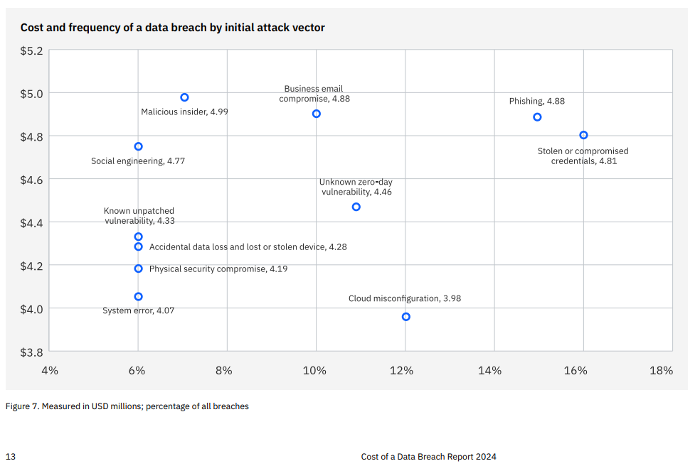
6% Valid credentials - social engineering
7% Valid credentials – malicious insider
11% Valid credentials - zero day (obtains credentials)
12% Valid credentials - cloud misconfiguration
15% Valid credentials - Phishing
16% Valid credentials - Stolen compromised credentials
67% total

Data Lifecycle (copies and derivatives of a Digital Asset and GID)
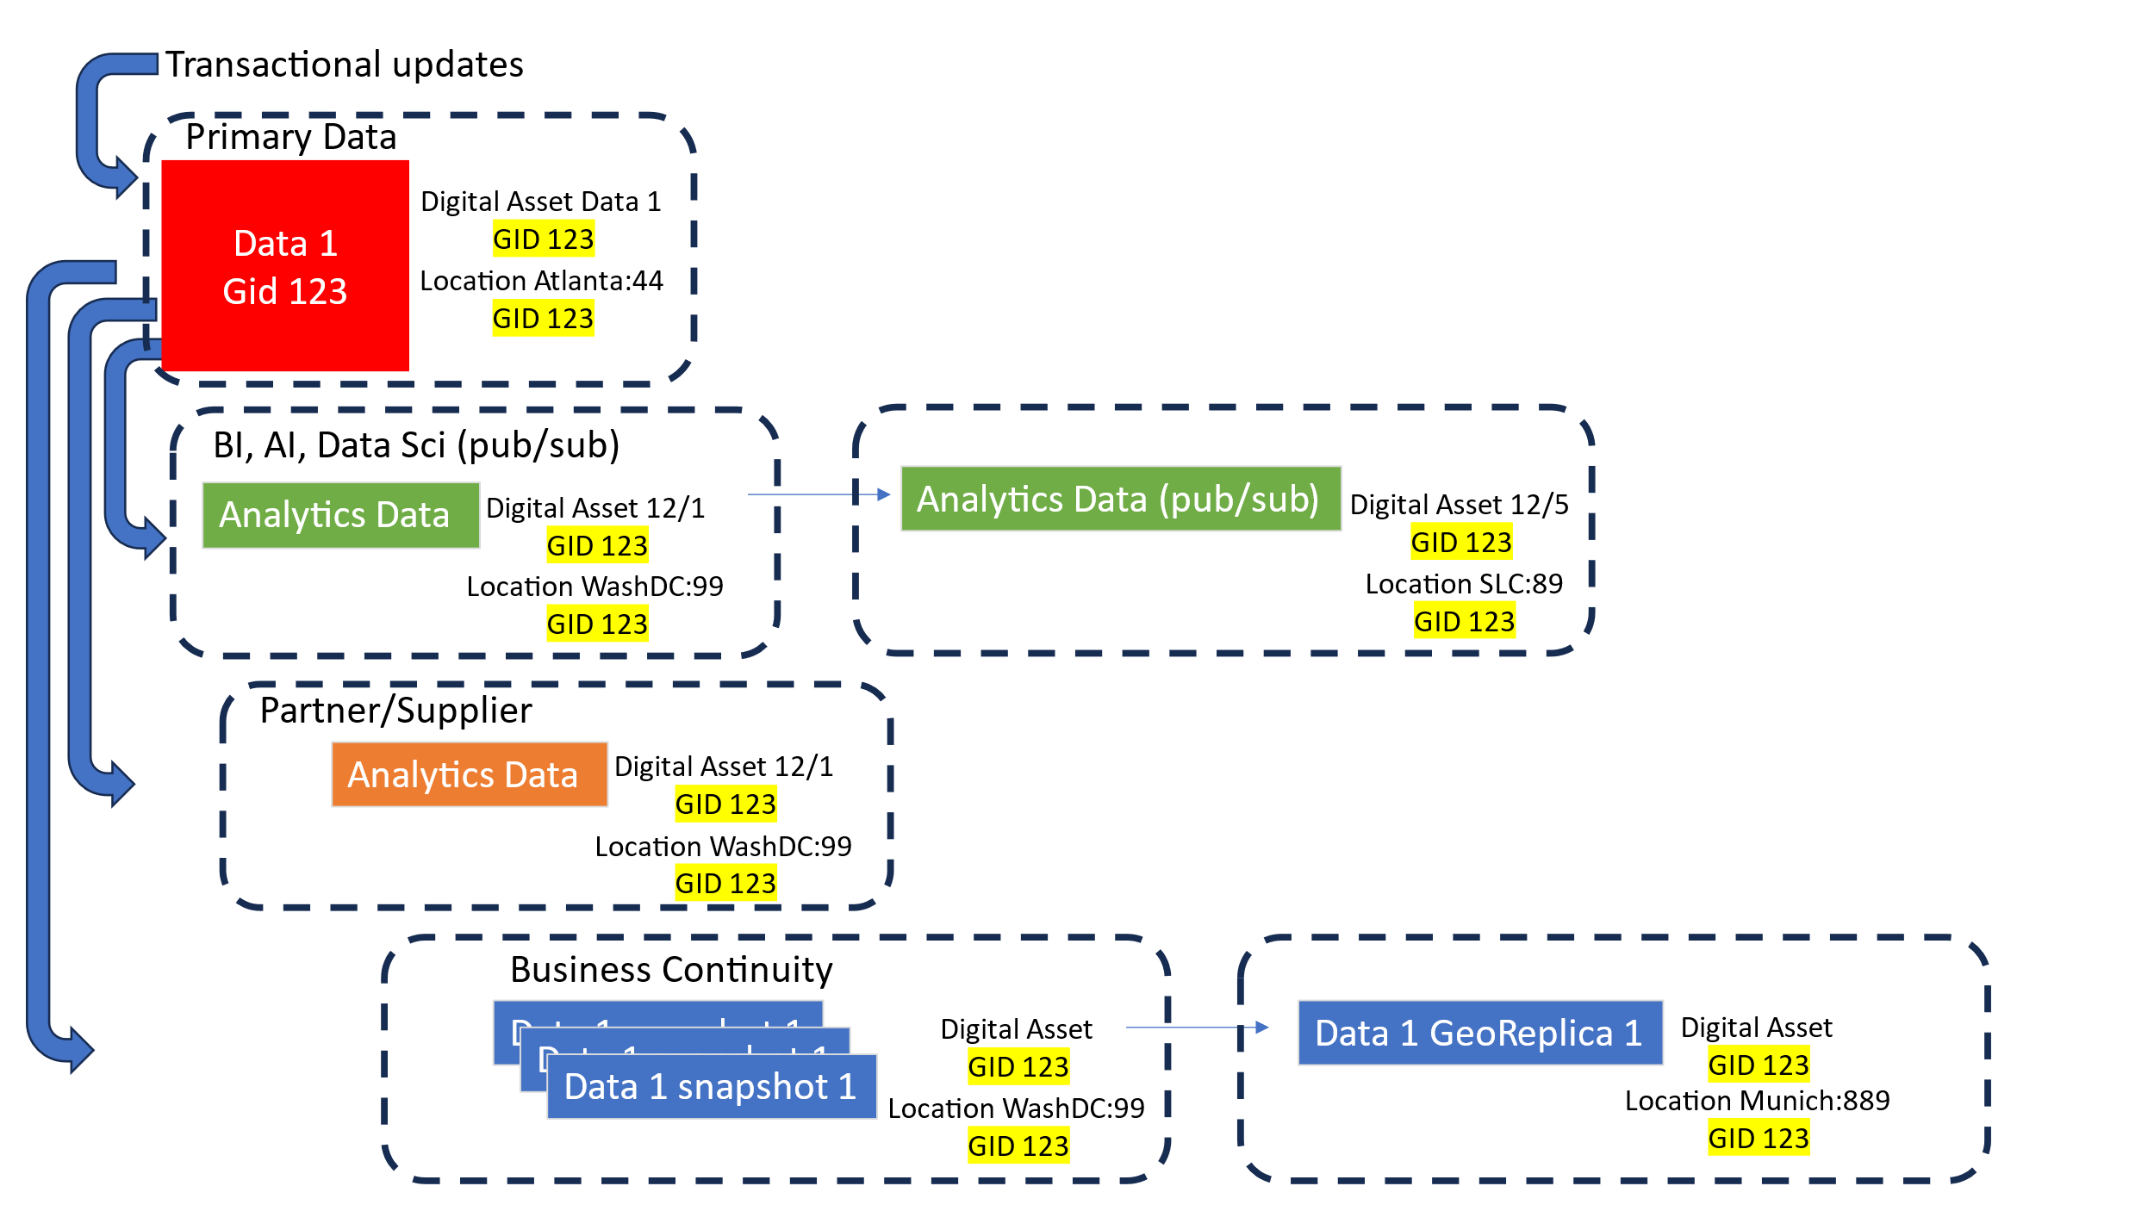

[Example] Digital Asset CATALOG based on policy-risk-profile
This Digital Asset Catalog with policies and tracking is essential for compliance.
This outlines minimum required functions and tracking.
Table ASSETS - AssetID, Asset name, Asset business owner, Asset policy/risk class
Table POLICIES - Policy, risk-classification, alert, action, access allowed policy, access prohibited policy
Table AsssetACCESS - Name, AssetID, Copy event, date, location, accessed by(people)

Verizon Data Breach 2023
https://www.verizon.com/business/resources/reports/dbir/
Key Points
- More likely: Human Element, Malicious insiders, stolen credentials
- Less likely: physical breaches at data center

CNCF Example Security Use Case
https://github.com/cncf/tag-security/tree/main/usecase-personas

